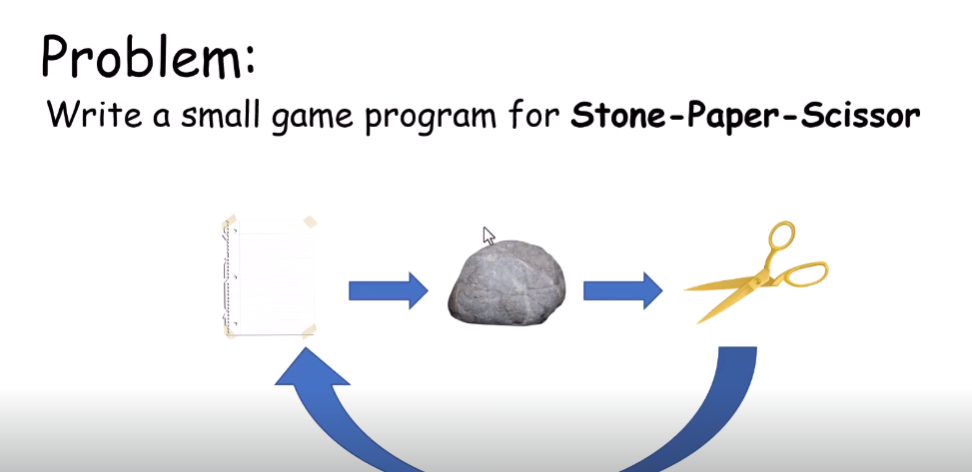
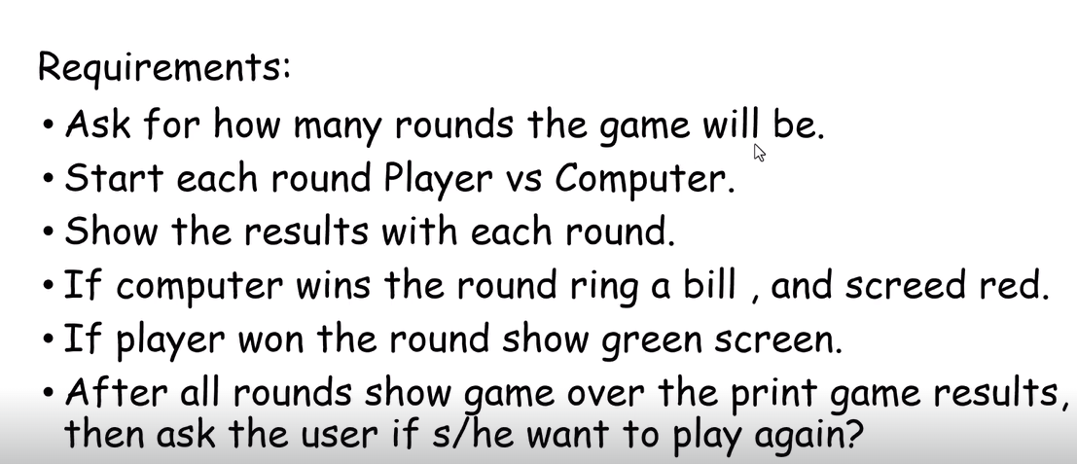

This Is A Simple Game For C++ Basic Concepts
You Are Facing The PC

Game Rules:
-Paper Defeats Stone
-Stone Defeats Scissors
-Scissors Defeats Papper

